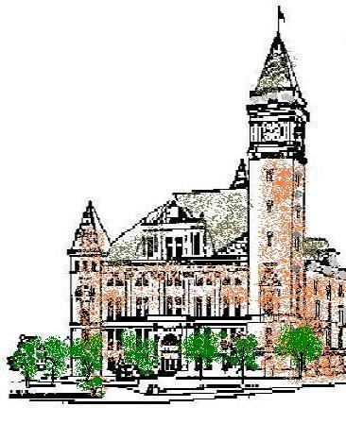**Agenda**

**Tipton County**

**Board of Zoning Appeals**

**August 4, 2021**

**7:00 p.m.**

The Tipton County Board of Zoning Appeals will hold its regular meeting on Wednesday, August 4, 2021, at 7:00 pm, in the 1st Floor Meeting Room of the Tipton County Courthouse, 101 East Jefferson Street, Tipton, Indiana. The agenda is as follows:

**Call to Order**

**Roll Call**

**Modifications to Agenda / Agenda Summation**

**Approval of Minutes**

a) June 2, 2021 Minutes

**Public Hearings**

a) CO-V-24-21 Mraz development standard variance

b) CO-V-25-21 Burrow use variance

**Old Business**

a) CO-V-17-21 McQuinn findings of fact

b) CO-V-18-21 Cripe findings of fact

**New Business**

None.

**Adjournment**