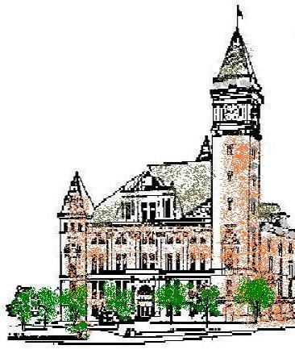**Agenda**

**Tipton County**

**Board of Zoning Appeals**

**December 6, 2023**

**7:00 p.m.**

Please note the change of meeting location.

The Tipton County Board of Zoning Appeals will hold its regular meeting on Wednesday, December 6, 2023, at 7:00 pm, in the meeting room of the Tipton County Foundation, 1020 W Jefferson St, Tipton, IN 46072. The agenda is as follows:

**Call to Order**

**Roll Call**

**Modifications to Agenda / Agenda Summation**

**Approval of Minutes**

a) November 1, 2023 Minutes.

**Public Hearings**

a) CO-V-29-23 Turner development standard variance. Tabled from November 1, 2023.

b) CO-CU-32-23 Fornax Solar Conditional Use. **NOTE: This public hearing shall begin no sooner than 7:30 pm.**

**Old Business**

b) CO-V-30-23 Co-Alliance development standard variance findings of fact.

c) CO-V-34-23 Walls development standard variance findings of fact.

**New Business**

a) None.

**Adjournment**