Sidewalk Improvement Program 2023

THOMAS E. DOLEZAL, MAYOR

MICHAEL TERRY, PUBLIC WORKS MANAGER

SIDEWALK IMPROVEMENT PROGRAM 2023

Table of Contents
Replacement Sidewalks 3
Repair Sidewalks 4
Design & Priority 5
Project Disclaimer & Terms 6
Payments 7
Frequently Asked Questions 8
Resolution…………………………………………………………………………………………………………………………………………………………………………… 9
Application……………………………………………………………………………………………………………………………………………………………………….. 10

Replacement Sidewalks

Participation Ratio: Based on Sidewalk Rating (table below)
  - Description: The City of Tipton will participate with the property owner at the rate identified in the table below. City of Tipton sidewalks will be given a rating according to its current condition
  - Funding Mechanism: City EDIT Fund and/or other City capital funds, including the General Fund
  - Applications for the program must be made in writing on approved forms.
  - These forms will be available at the Street Department Office, City Hall and on the City’s website (www.tiptongov.com/city).

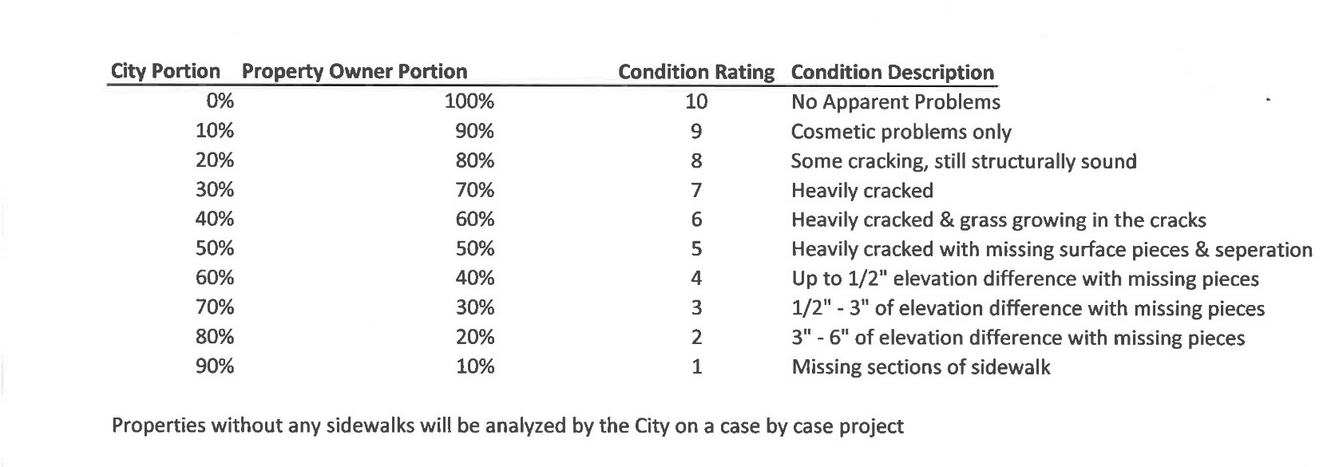

Repair Sidewalks

Participation Ratio: 100% City of Tipton

  - Funding Mechanism: City EDIT Fund and/or other City capital funds, including the General Fund
  - Applications for the program must be made in writing on approved forms. These forms will be available at the Street Department Office, City Hall, and on the City’s website (www.tiptongov.com/city).
  - Any application where the total length of sidewalk to be repaired is greater than 30% of the total sidewalk length shall not be eligible for a Repair, but rather should reference section 1 – Replacement.

Design & Priority

Design Standard
- Corner ramp panels and alley ramp panels will be constructed to conform with current requirements for handicap accessibility and the cost for those sections will be 100% paid by City. ADA compliance will be determined by the ADA coordinator, or by his/her designee.
- Projects with intersecting service walks and/or driveways will be reconnected as part of the project in a manner as determined by the Administrator and 100% of the costs of connection will be paid by the property owner or as determined by the Administrator.

Project Priority
- Construction priority will be determined by the Program Administrator with preference being giving to projects with the longest uninterrupted length of walk. Intersecting streets and alleys will not be considered to be interruptions.
- Projects of similar length will be assigned a construction priority by the Program Administrator with preference being given to the average condition ranking of the existing walks. If no ranking system is in place, the Program Administrator will assign the construction priority. Projects with the worst average ranking will receive preference. The ranking system referred to is the current ranking system or its successor system.
- The sidewalk condition ranking system is a separate internal process of the Tipton Street Department and is a dynamic process that will result in re-ranking of sidewalks during the time of this program.
- Projects will be carried over at the beginning of each calendar year and will then be placed at the top of the priority list. Preference will be given to these projects based on uninterrupted length and condition ranking.
- Any project regardless of uninterrupted length or condition ranking will be given a priority preference if the application remains active for 18 months without construction being started.

Project Disclaimer & Terms

- The City of Tipton will bear the cost of all debris removal in connection with construction on any project.
- Lawns, fences, landscaping, walls and other adjoining appurtenances that may be removed, damaged or destroyed by construction will be replaced at sole discretion and expense of the property owner. However, in all cases the property owner will manage and pay the full cost of backfill and seeding as necessitated by project construction.
- All projects will be the subject of a written cost estimate by the Administrator, which will then be allocated by property owner. Cost estimate detail and allocated methods will be at the discretion of the Administrator.
- Property lines will be the basis for allocating property owner’s share of the project. Property lines will be assumed in a good faith manner and shall not be subject to dispute unless supported by a staked boundary survey provided by the property owner.
- Notice of project will be by paid advertising and unpaid news articles in newspapers of general circulation, City website, flyers placed or posted in public places and mailings to utility customers using bulk mail. Costs connected with notice will be paid from the Program.
- The program Administrator will facilitate all necessary permits in connection with any project and will insure that applicable codes and specifications are adhered to.
- All applications shall be made by property owner and non-owner occupants must work through the property owner to become a part of the Program.
- An application will be required from each property owner. Each application will be a project until such time as it is grouped with adjoining applications and becomes a new project.
- Brick sidewalks will be replaced with concrete at 100% cost to the City of Tipton at the city’s discretion regarding schedule. However, property owners with brick sidewalks may make application under the 80%-20% program and the project will then be treated in the same manner as all other non-brick sidewalk projects.
- Bricks removed from sidewalks as part of the Repair Program or the Replacement Program shall be the property of the City of Tipton and not the property owner.

Payments

- All payments shall be made in the Clerk-Treasurers Office and payable to the City of Tipton Sidewalk Program. The Clerk-Treasurer will determine or approve invoice, payment and note procedures.
- Payment, in the form of check or promissory note, will be due in the Clerk-Treasurers office at least 30 days prior to the expected start of construction. Notice of the expected start of construction will be given to the property owner at least 40 days prior to the expected start of construction.
- Property owners may pay in full by check or by signing an interest free promissory note to the City of Tipton. The note will be payable over 24 equal monthly payments. Payments will be due the 1st day of the 1st month following the completion of the project. Each subsequent payment will be due at the beginning of each month.
Loan Forgiveness

- A property owner has the opportunity to have their loan forgiven, for cause, if the following conditions are met:
  - Property owner must make 12 consecutive payments in full and on time.
  - Property must have been in good standing with the City of Tipton during the same
12-month duration coinciding with 12 consecutive payments.
- The Board of Public Works will be the approving authority for all loan forgiveness. Furthermore, loan forgiveness can only be granted during a public meeting.

Hardship Determination

- The program administrator shall have the authority to make hardship determinations thereby providing that wherever possible replacement sidewalks and additional sidewalks shall be extended from intersection to intersection without gaps that otherwise would occur.

Frequently Asked Questions

HOW MUCH WILL MY IMPROVEMENT COST, AND WHEN WILL I KNOW?
The Sidewalk Program Administrator will review each application, inspect each site, and calculate the cost of the improvements at that site. A letter will be sent to the applicant, advising of the cost and asking for agreement. The applicant will then have ten (10) days in which to respond to The Sidewalk Program Administrator.

WHEN WILL WORK BEGIN ON MY SIDEWALK OR CURB AREA?
The Sidewalk Program Administrator will be notifying the applicant as soon as that site is scheduled with a start date and deadline date.

DO I, OR CAN I, PICK MY OWN CONTRACTOR?
No - The Sidewalk Program Administrator will be receiving bids from contractors interested in bidding for this work.

WHAT IF I’M NOT SATISFIED WITH THE WORK DONE IN FRONT OF MY PROPERTY?
Contact the Administrator at 765-675-3331 as soon as the problem is noticed.

DO I PAY THE CONTRACTOR OR THE CITY OF TIPTON?
Applicants will make all payments for their portion directly to the City of Tipton. The City will make payment to the Contractor.

RESOLUTION
2023-07

A RESOLUTION ADOPTING THE 2023 SIDEWALK IMPROVEMENT PROGRAM AND FUNDING

WHEREAS the City Council of the City of Tipton, Indiana, in consultation with the Mayor of the City of Tipton has determined that sidewalks in the corporate limits are in disrepair in many areas and non-existent in some areas; and

WHEREAS said sidewalks are located within the platted rights-of-way for streets; and

WHEREAS said City rights-of-way adjoin various and diverse properties owned by others; and

WHEREAS the City of Tipton and the Owners would benefit from the repair, replacement, and addition of sidewalks within the corporate limits; and

WHEREAS the City of Tipton Common Council has appropriated from the 2023 General Fund Council Budget $75,000.

NOW THEREFORE BE IT RESOLVED that the City of Tipton Common Council now hereby adopts the revised Sidewalk Program for the City of Tipton and the guidelines of which are attached hereto and titled SIDEWALK IMPROVEMENT PROGRAM 2023 and which shall bear the date adopted and the date(s) revised and which guidelines shall be adhered to by the administering parties until modified or revised by action of said Council; and

BE IT FURTHER RESOLVED that it be made known hereby that it is intended that this Resolution is a continuation in an unbroken series of resolutions to be adopted by this and future City Councils to improve the general and aggregate conditions of the sidewalks located in the corporate limits of the City of Tipton.

This RESOLUTION and accompanying SIDEWALK IMPROVEMENT PROGRAM are hereby adopted this 27 th day, of March, 2023 by the City of Tipton Common Council.

Rick Chandler, Council President Sophie Hufford, Councilwoman

Ken Ehman, Councilman Nate Kring, Councilman

Richard Rippy, Councilman

Attest:
Thomas E. Dolezal, Mayor Tamera L. Clark, Clerk-Treasurer

Prepared by Tamera Clark, Clerk-Treasurer
Reviewed by Matthew B. Quigley, Attorney for the City of Tipton _______

CITY OF TIPTON
APPLICATION FORM
SIDEWALK PROGRAM

NAME DATE

STREET ADDRESS TIPTON, INDIANA 46072

DAYTIME PHONE

COMPLETE THE INFORMATION BELOW AND RETURN TO EITHER:

City Hall – Mayor’s Office | Tipton Street Department
216 S. Main Street | 500 Green Street
Tipton, Indiana 46072 | Tipton, Indiana, 46072

Please check type of improvement you wish to make:

SIDEWALK CURB
All sidewalk needs to be replaced
Only bad areas need to be replaced
Sidewalk is cracked, shifted
Sidewalk ponds water
Sidewalk is a trip hazard
No sidewalk exists

All curbing needs to be replaced Only bad areas need to be replaced Curbing is sunken
Curb is broken, cracked No curb exists
Need curbing to close a drive that has been removed

DRIVEWAY APPROACH
Approach sunken, needs to be replaced
FOR OFFICE USE ONLY: CORNER LOT ZONE
APP. NO.
VERIFIED CASH/ RECEIPT INSTALLMENTS COMMMENTS ___________
__________________________________________________________
Approach is cracked, shifted
Ponds water
Please remove, but not replace

