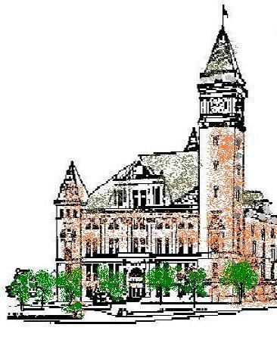
Agenda
Tipton County
Plan Commission
November 4, 2021
6:00 p.m.

The Tipton County Plan Commission will hold a regularly scheduled meeting on Thursday, November 4, 2021, at 6:00 p.m., in the 1st floor meeting room, Tipton County Courthouse, 101 East Jefferson Street, Tipton, Indiana. The agenda is as follows:

Roll Call

Modifications to agenda

Approval of Minutes
a) Minutes of October 7, 2021

Public Hearings
a) None.

Reports
a) Staff reports
b) Standing Committee reports

Old Business
Area Wide Planning Discussion.

New Business

Public Comments

Adjournment

