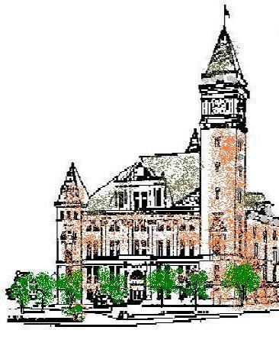
Agenda
Tipton County
Plan Commission
October 7, 2021
6:00 p.m.

The Tipton County Plan Commission will hold a regularly scheduled meeting on Thursday, October 7, 2021, at 6:00 p.m., in the 1st floor meeting room, Tipton County Courthouse, 101 East Jefferson Street, Tipton, Indiana. The agenda is as follows:

Roll Call

Modifications to agenda

Approval of Minutes
a) Minutes of August 5, 2021

Public Hearings
a) CO-Z-21-22 Henderson rezoning

Reports
a) Staff reports
b) Standing Committee reports

Old Business
None.

New Business

Public Comments

Adjournment

