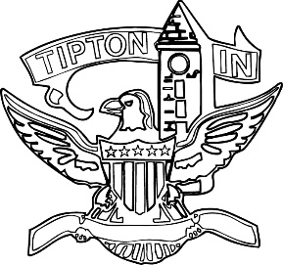
Agenda
City of Tipton
Board of Zoning Appeals
April 12, 2023
6:00 p.m.

The City of Tipton Board of Zoning Appeals will hold its regularly scheduled meeting on Wednesday, April 12, 2023, at 6:00 p.m., at the Tipton City meeting room, 216 South Main Street, Tipton, Indiana.

Call to Order and Pledge of Allegiance

Roll Call

Modifications to Agenda

Election of Officers
- Chairman
- Vice-Chairman
- Secretary

Approval of Minutes
a) December 14, 2022 Regular Meeting Minutes

Public Hearings
a) None.

Old Business
a) CTI-V-27-22 Young development standard variance Findings of Fact
a) CTI-V-40-22 McCord development standard variance Findings of Fact

Adjournment

