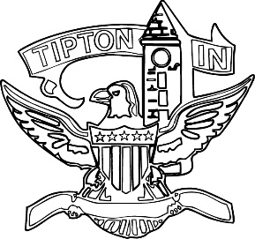
Agenda
City of Tipton
Plan Commission
September 12, 2024
6:00 p.m.

The City of Tipton Plan Commission will hold its regularly scheduled meeting on Thursday, September 12, 2024, at 6:00 p.m., at the Tipton City Building meeting room, 216 South Main Street, Tipton, Indiana.

Call to Order and Pledge of Allegiance

Roll Call

Modifications to the Agenda

Approval of Minutes
a) August 15, 2024, Meeting Minutes.

Public Hearings

a) None.

Staff Reports

a) City BZA report.

Old Business
a) Standing Committee.

New Business
a) City of Tipton Downtown EDA Resolution
b) City of Tipton HP Alloys EDA Resolution
c) Solar Ordinance Draft

Public Comment

Adjournment

