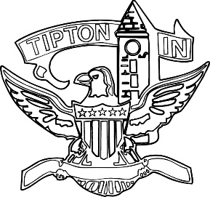
Agenda
City of Tipton
Plan Commission
March 14, 2024
6:00 p.m.

The City of Tipton Plan Commission will hold its regularly scheduled meeting on Thursday, March 14, 2024, at 6:00 p.m., at the Tipton City Building meeting room, 216 South Main Street, Tipton, Indiana.

Call to Order and Pledge of Allegiance

Roll Call

Modifications to the Agenda

Approval of Minutes
a) January 11, 2024 Meeting Minutes

Public Hearings

a) None.

Staff Reports

a) City BZA report.

Old Business
a) Standing Committee.

New Business
a) None.

Public Comment

Adjournment

