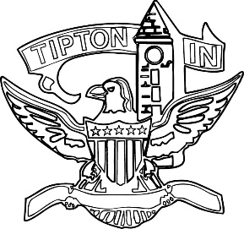
Agenda
City of Tipton
Plan Commission
October 12, 2023
6:00 p.m.

The City of Tipton Plan Commission will hold its regular meeting on Thursday, October 12, 2023, at 6:00 p.m., at the Tipton City Building meeting room, 216 South Main Street, Tipton, Indiana.

Call to Order and Pledge of Allegiance

Roll Call

Modifications to the Agenda

Approval of Minutes
a) September 14, 2023 Meeting Minutes

Public Hearings
a) CTI-ZO-26-23 Section 403.04 Amendment (Downtown Overlay Tattoo Parlors) – Continued from September.

Staff Reports

a) City BZA report
b) Enforcement and Permit report

Old Business
a) Standing Committee
b) Accessory Dwelling Unit discussion

New Business

Public Comment

Adjournment

