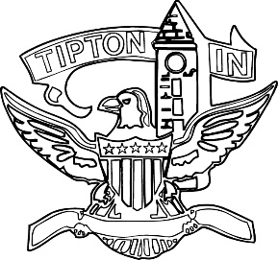
Agenda
City of Tipton
Plan Commission
April 13, 2023
6:00 p.m.

The City of Tipton Plan Commission will hold its regularly scheduled meeting on Thursday, March 9, 2023, at 6:00 p.m., at the Tipton City Building meeting room, 216 South Main Street, Tipton, Indiana.

Call to Order and Pledge of Allegiance

Roll Call

Modifications to the Agenda

Approval of Minutes
a) February 9, 2023, Regular Minutes

Public Hearings

a) CTI-DP-04-23 High Performance Alloys

Staff Reports

a) City BZA report
b) Enforcement and Permit report

Old Business
a) Standing Committee

New Business
a) Electronic attendance discussion / resolution

Public Comment

Adjournment

