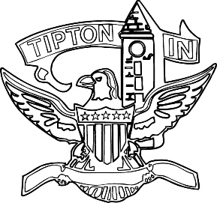
Agenda
City of Tipton
Plan Commission
December 9, 2021
6:00 p.m.

The City of Tipton Plan Commission will hold its regularly scheduled meeting on Thursday, December 9, 2021, at 6:00 p.m., at the Tipton City Building meeting room, 216 South Main Street, Tipton, Indiana.

Call to Order and Pledge of Allegiance

Roll Call

Modifications to the Agenda

Approval of Minutes
a) Minutes of November 10, 2021

Public Hearings

a) CTI-PUD-34-21 Arbor Homes - Continuation

Staff Reports

a) City BZA report
b) Enforcement and Permit report

Old Business
a) Standing Committee

New Business

Public Comment

Adjournment

