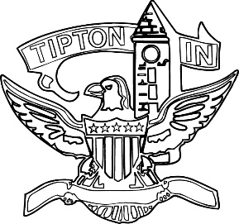
Agenda
City of Tipton
Plan Commission
November 10, 2021
6:00 p.m.

Note Change of Date.

The City of Tipton Plan Commission will hold its regularly scheduled meeting on Wednesday November 10, 2021, at 6:00 p.m., at the Tipton City Building meeting room, 216 South Main Street, Tipton, Indiana.

Call to Order and Pledge of Allegiance

Roll Call

Modifications to the Agenda

Approval of Minutes
a) Minutes of October 14, 2021

Public Hearings

a) CTI-PUD-34-21 Arbor Homes

Staff Reports

a) City BZA report
b) Enforcement and Permit report

Old Business
a) Standing Committee

New Business

Public Comment

Adjournment

