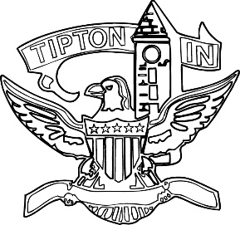
Agenda
City of Tipton
Plan Commission
August 12, 2021
6:00 p.m.

The City of Tipton Plan Commission will hold its regularly scheduled meeting on Thursday, August 12, 2021, at 6:00 p.m., at the Tipton City Building meeting room, 216 South Main Street, Tipton, Indiana.

Call to Order and Pledge of Allegiance

Roll Call

Modifications to the Agenda

Approval of Minutes
a) June 10, 2021 Meeting Minutes

Public Hearings

a) CTI-DP-26-21 Coomler for McCreery Concrete

Staff Reports

a) City BZA report
b) Enforcement and Permit report

Old Business
a) Standing Committee

New Business

Public Comment

Adjournment

