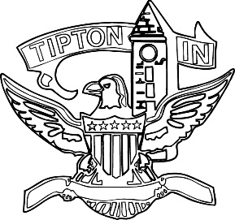
Agenda
City of Tipton
Board of Zoning Appeals
August 11, 2021
6:00 p.m.

The City of Tipton Board of Zoning Appeals will hold its regularly scheduled meeting on Wednesday, August 11, 2021, at 6:00 p.m., at the Tipton City Building meeting room, 216 South Main Street, Tipton, Indiana. The agenda is as follows:

Call to Order and Pledge of Allegiance

Roll Call

Modifications to Agenda

Approval of Minutes
a) July 14, 2021 Regular Meeting Minutes

Public Hearings
a) CTI-V-27-21 Red Diamond Use Variance

Old Business
a) CTI-V-23-21 LaBoyteaux Findings of Fact

Adjournment

