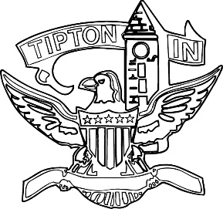
Agenda
City of Tipton
Plan Commission
July 15, 2021
6:00 p.m.

The Regular Meeting of the Tipton City Plan Commission scheduled for Thursday July 15, 2021 has been cancelled.

